**ASR Failover Code Execution Steps**

**Step 1:** Source/Primary Location Resources. These are the existing resources which will be protected for failover.

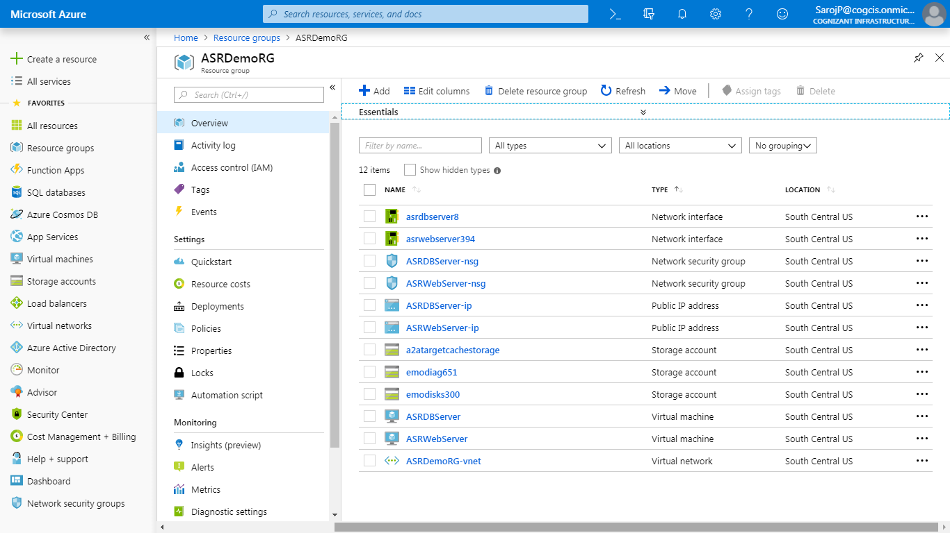

**Step 2:** Export all the necessary resource information to a csv file or fill manually. Which will be needed during failover process.

Run “**00ASRVMDetailsFileCreate.ps1**” file. It will create a csv file like below.



**Step 3:** Run “**02ASRMasterTemplate.ps1**” (internally call to “**01ASRvaultCreation.ps1**” for recovery service vault creation) to create a new resource group for service vault in different location,RecoveryService Vault recovery region, Vnet and Storage account etc. like below.

Script Status:

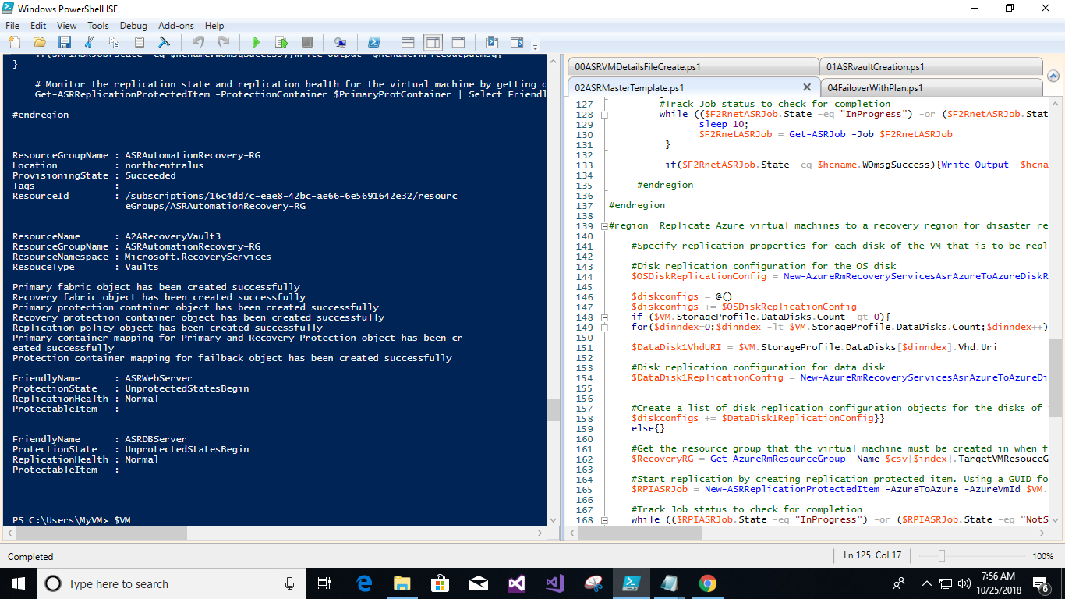

Resources list:

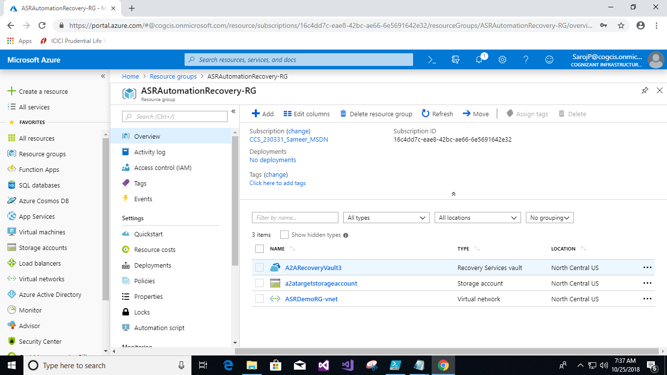

Recovery service vault Job competed status:

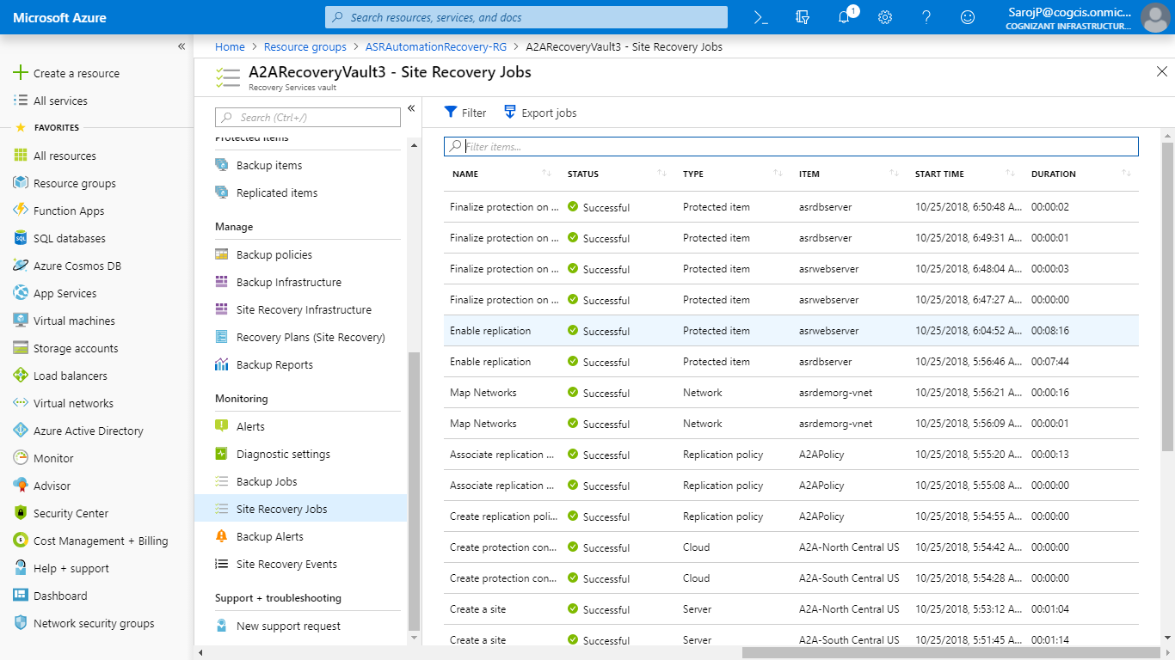

Protected Items:

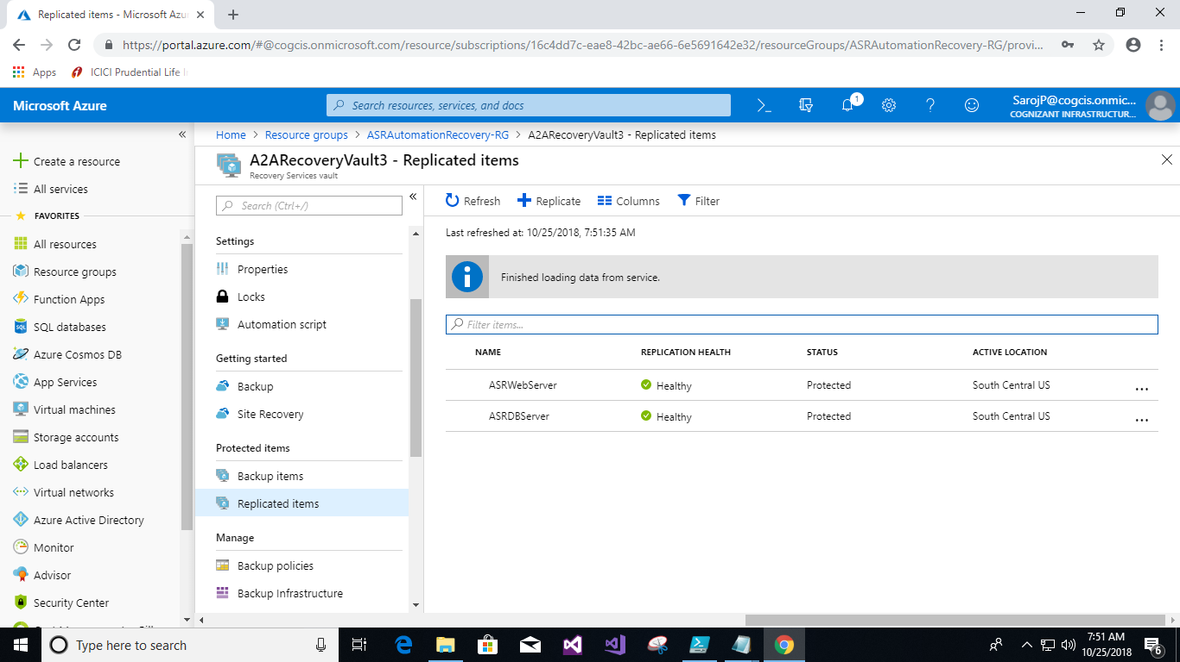

**Step 4:** Run “**04FailoverWithPlan.ps1**” for failover.

**NOTE:** Run the selection part of the code first for Plan creation, then run all the code for failover.

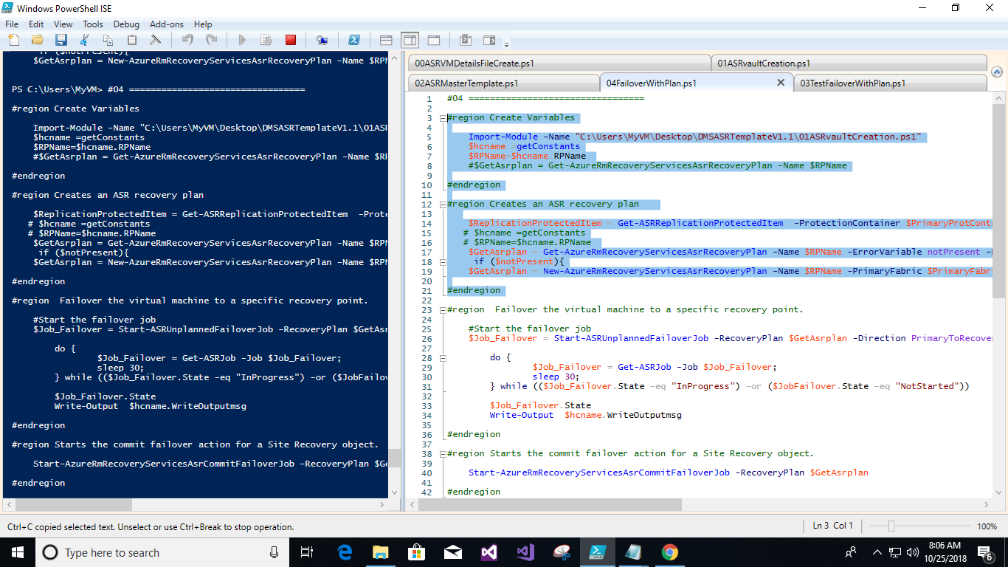

Script status after ran successfully

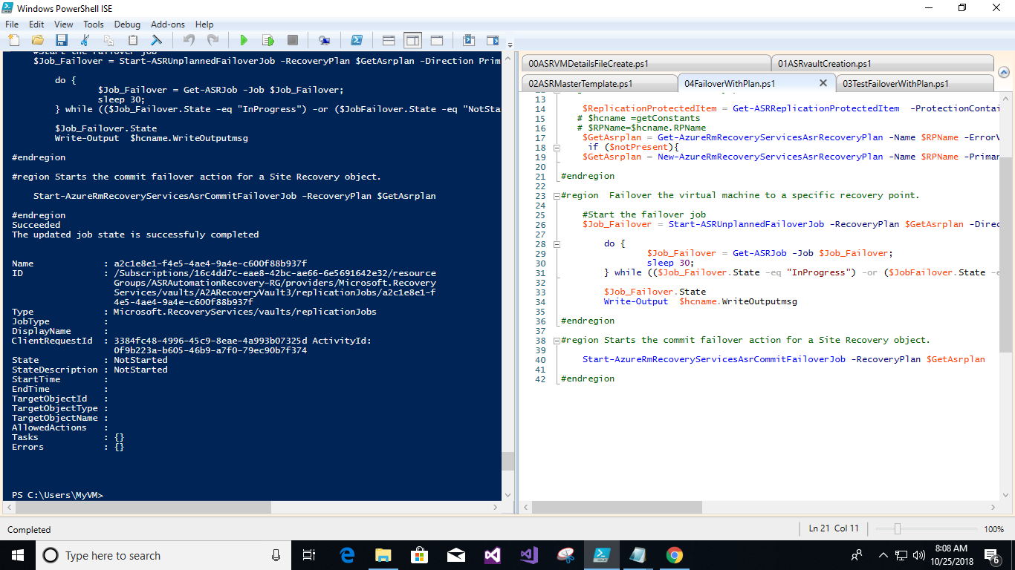

Resources list after failover in recovery region:

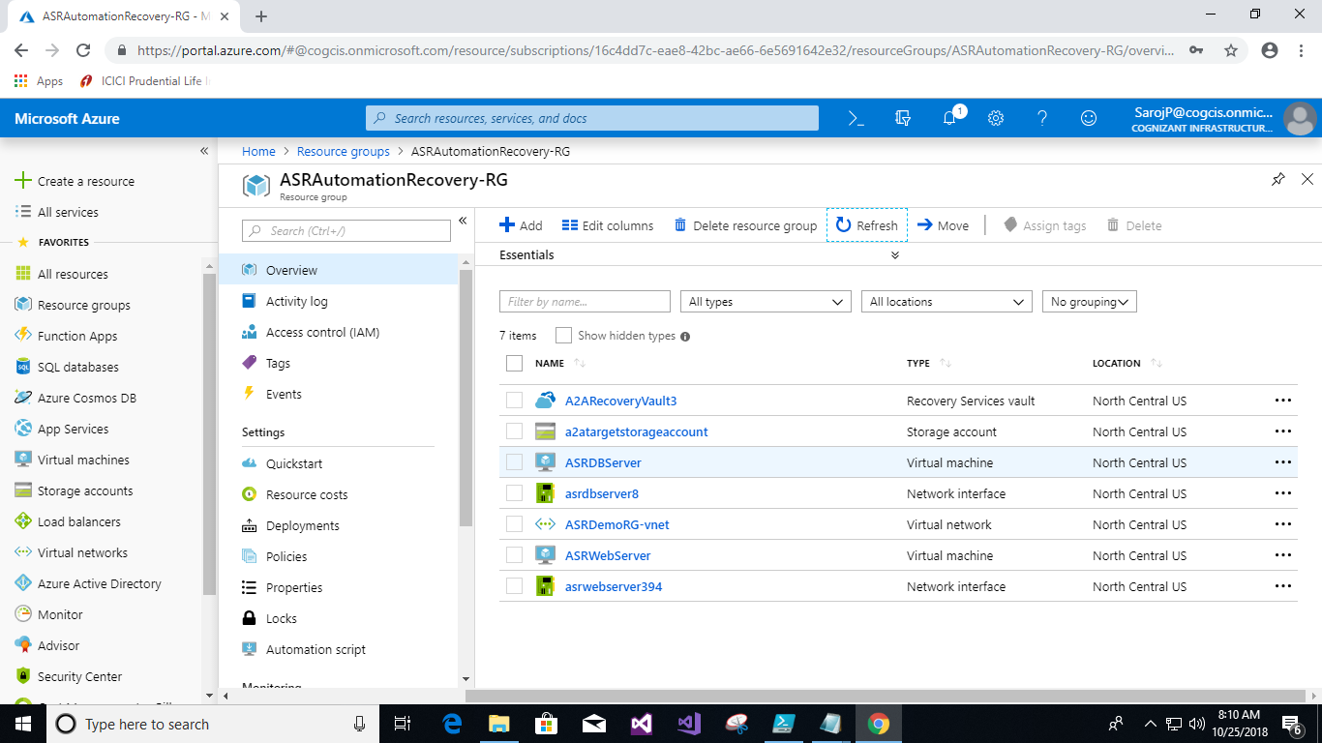

Now you can see the replicated items in service vault, it will look like.

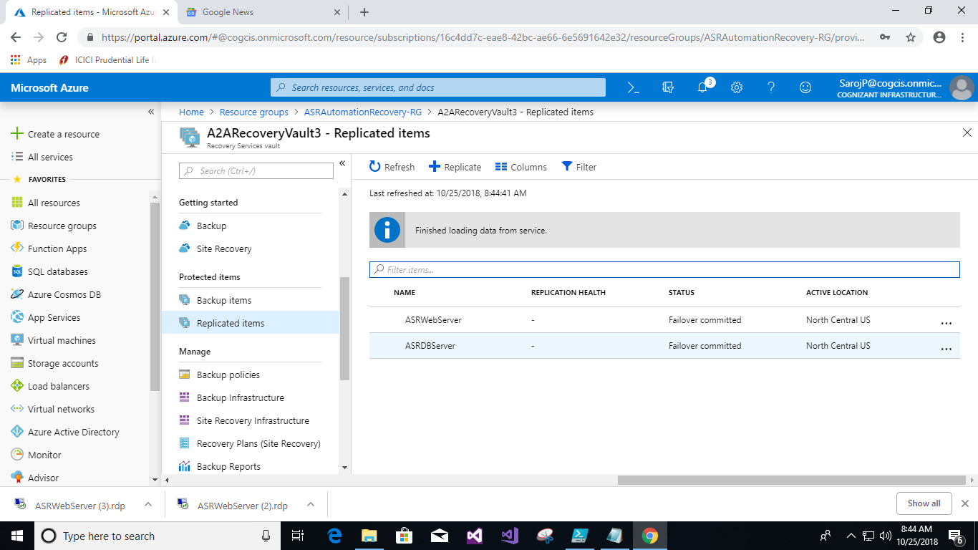

And the site recovery job look like

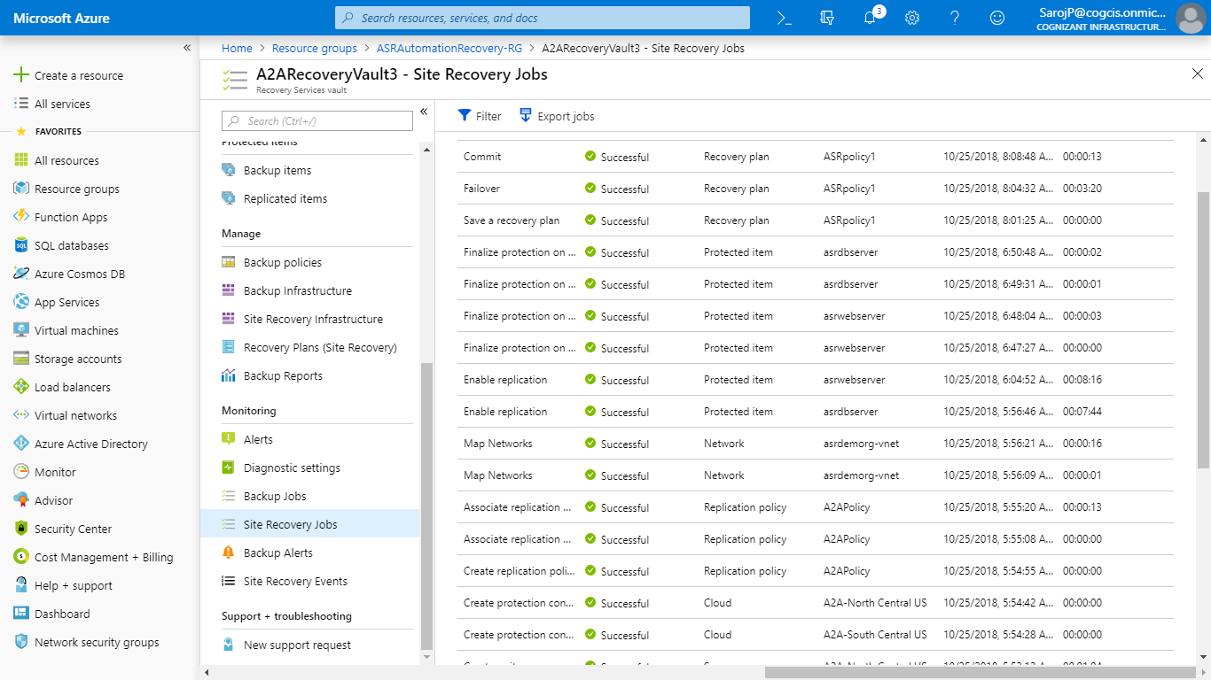

**Step 5:** Run “**05FailbackWithReplicationProtectedItem.ps1**” for failback.

**NOTE:** Run the selection part of the code first for re-protect, then run all the code for failback.

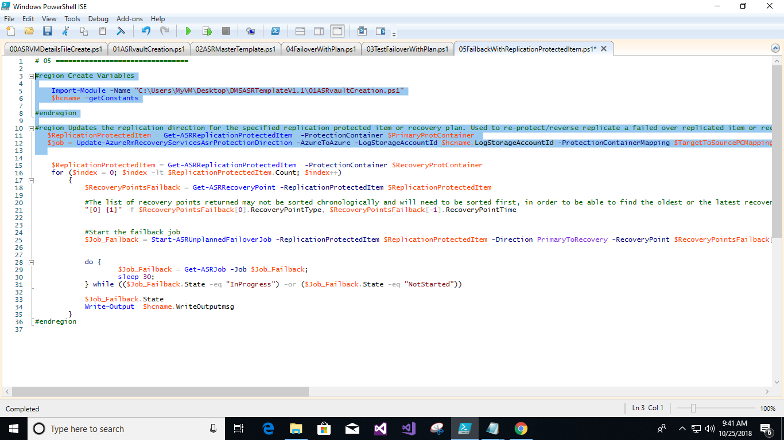

After re-protected you can see in portal look like this.

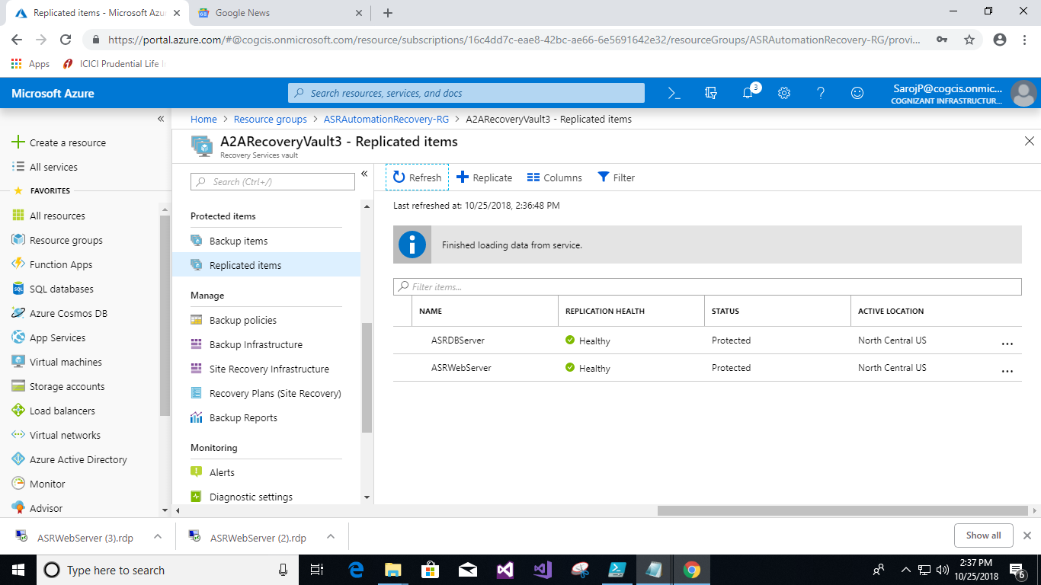

Then run rest of the code

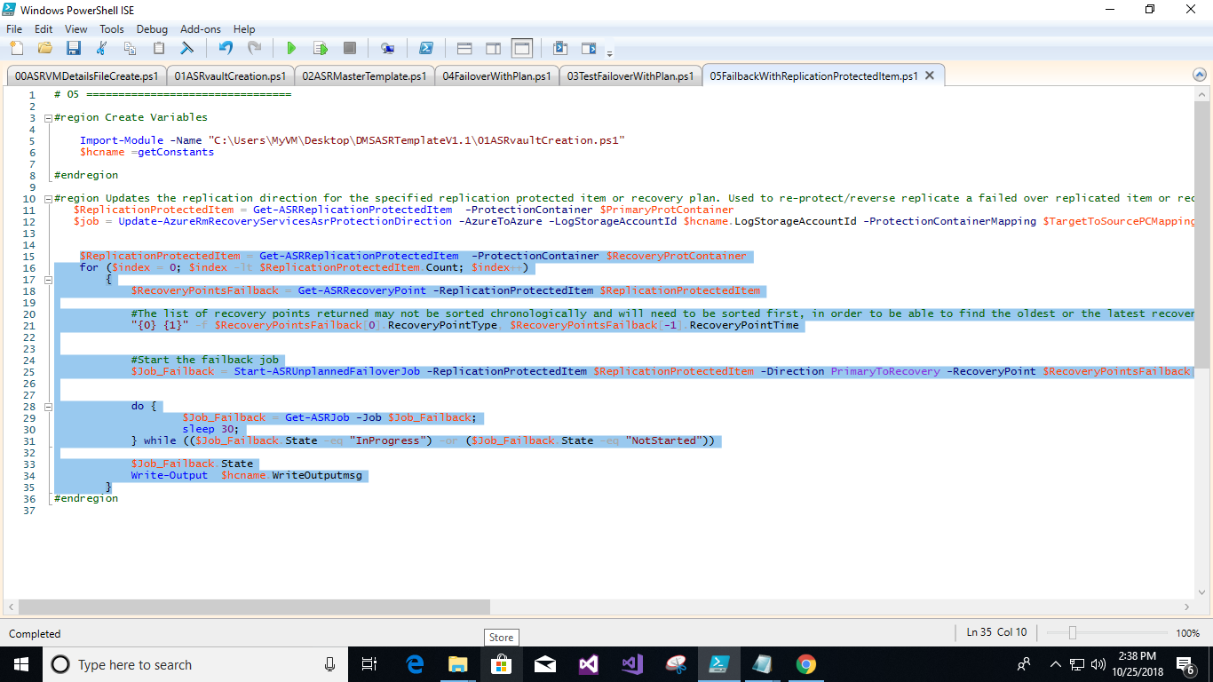

Resources list before fail back:

Resource Group:” **ASRAutomationRecovery-RG**” It was secondary/recovery region but it will treat as primary for failback after reprotect

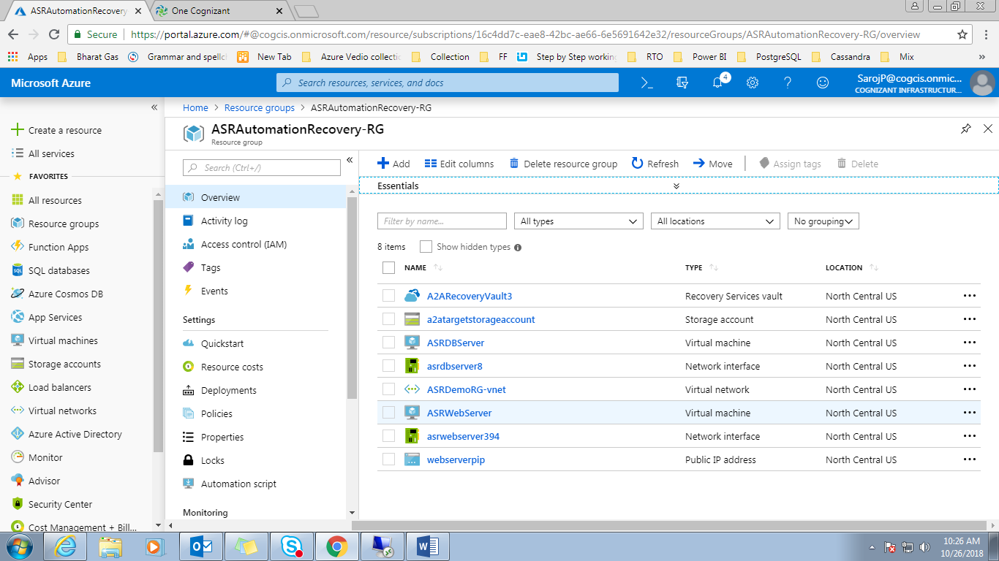

Resource Group:” **ASRDemoRG**” It was primary/source region but it will treat as secondary/recovery for failback after reprotect

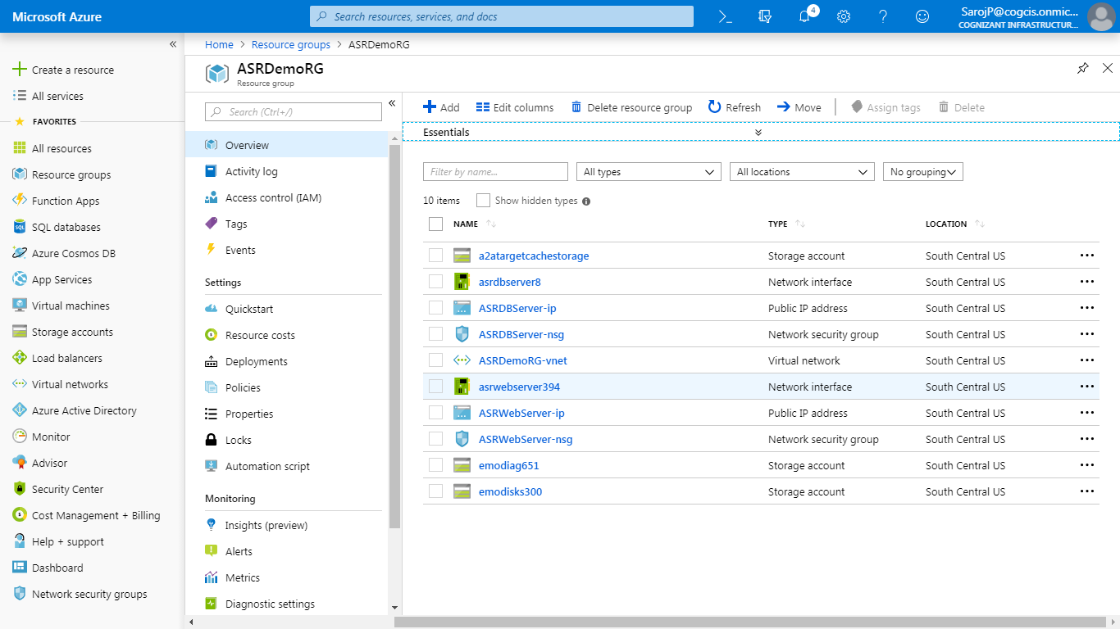

Then run failback code

Code status after ran code succesfully

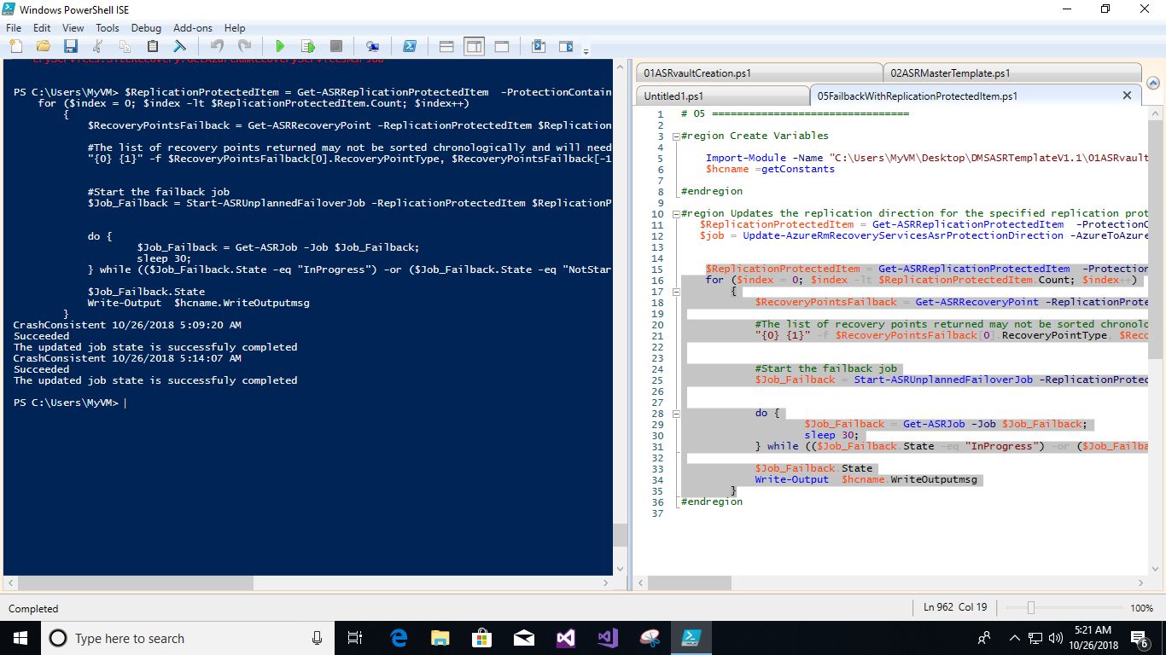

After failback the site recovery job look like

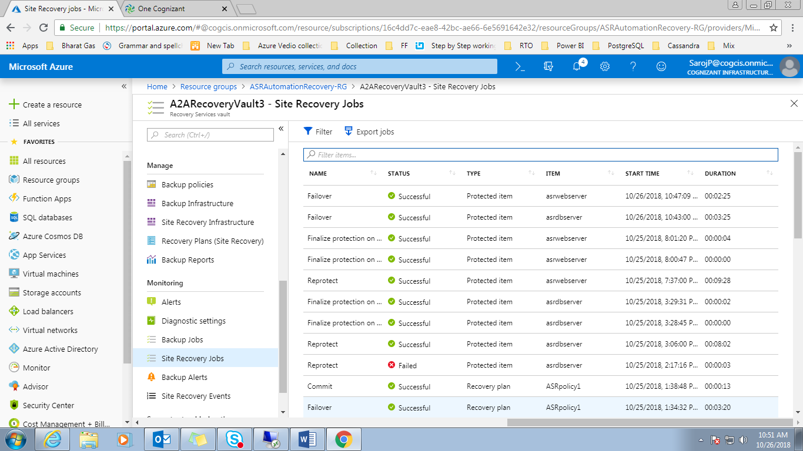

Resource list after failback in Resource Group:” **ASRDemoRG**”

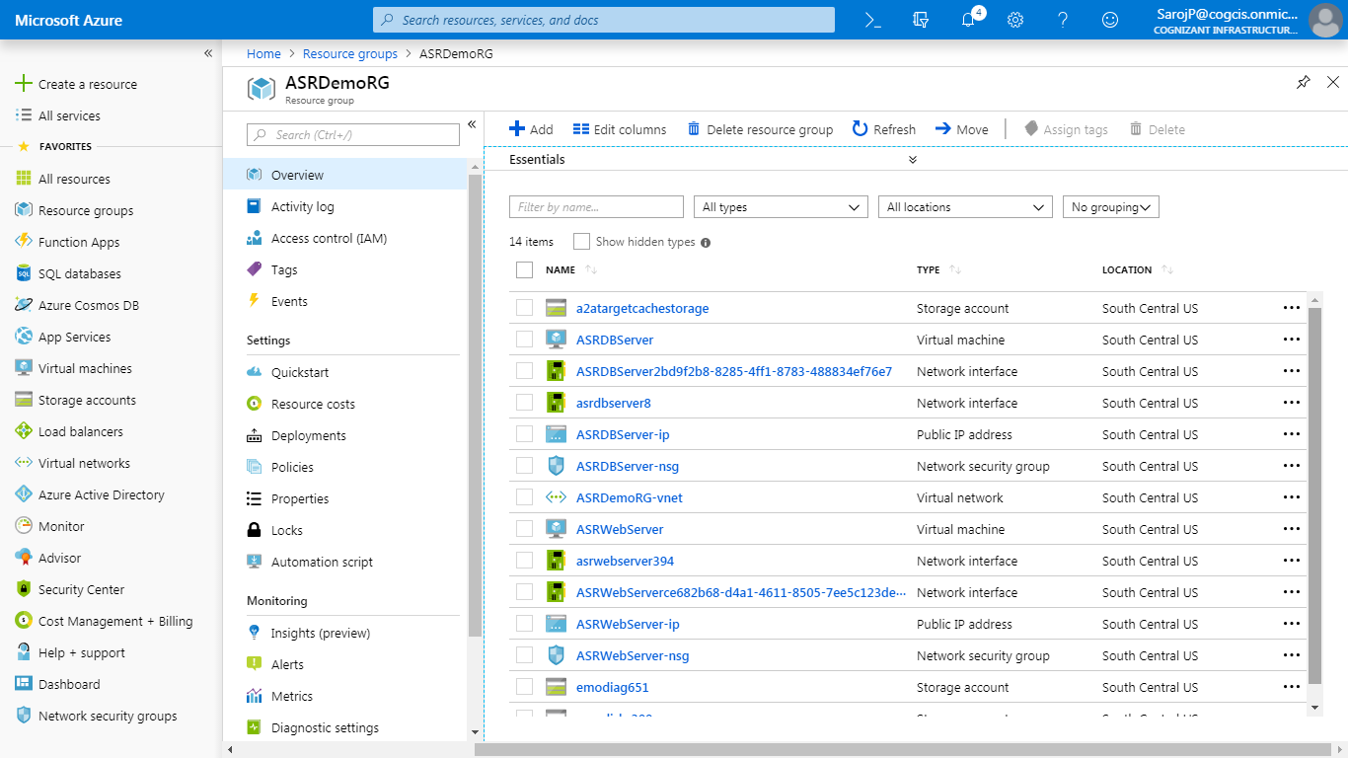

Both VM working fine after failback (After failback you should associate PIP in VM)